From The Farm — Research Document

Introduction
Small scale and emerging farmers in South Africa face persistent barriers to reaching reliable buyers, with only around 12% of the country's 2.4 million smallholder farming households selling any produce at all, due to a lack of direct market access beyond middlemen or word of mouth. This report examines three existing Android applications operating in adjacent problem spaces to From The Farm, a proposed app that matches farmers' produce listings with nearby buyer demand within a configurable radius. Its purpose is to evaluate how comparable applications approach farmer to buyer matching and market access, identifying gaps and design opportunities that inform the upcoming Planning and Design Document.
The three applications selected are Khula! Inputs & Trader, Farmer's Market, and Farmsell, each chosen for addressing at least part of the same problem space: connecting agricultural producers with buyers, reducing reliance on middlemen, and operating within a South African or broader African smallholder context. The report proceeds with a Competitive Analysis for each app, covering Overview, Strengths and Weaknesses, Technical Implementation Theory, and Interface Architecture, followed by a Comparison Matrix and a Conclusion linking these findings to the Planning and Design Document.

Competitive Analysis

App 1: Khula! Inputs & Trader

Overview of the App
Khula! Inputs is a free Android application, with over 10,000 downloads on the Google Play Store, that lets farmers order agricultural inputs such as seed, fertiliser, and crop protection from trusted suppliers, delivered to their farm. Direct inspection confirms it is a full e commerce catalogue rather than a simple order form: products sit under categories including Infrastructure, Seedlings, Farm Equipment, Animal Health, Seed, Crop Protection, and Crop Nutrition, alongside a shop by supplier section grouping items by brand, for example AECI, Bayer, and Kynoch. Pricing displays excluding VAT, with sort, filter, and a list or grid toggle. The entire browsing experience is accessible without an account; login only gates checkout, a low friction pattern well suited to smallholder users. It sits within a wider Khula ecosystem alongside a separate Trader app, a marketplace where buyers and suppliers manage availability, place orders, and handle payments. Khula! was founded in 2016 by Karidas Tshintsholo, Matthew Piper, and Jackson Dyora, piloting with around 400 farmers before growing to over 7,000 active users and has secured a $1.3 million seed round in 2020 and a roughly $6.76 million Series A round in March 2025 from investors including AECI, E Squared Investments, Absa Bank, and PepsiCo's Kgodiso Development Fund (Dealroom.co, 2026). The target audience spans emerging farmers through to larger commercial operations, with the core use case being input procurement or direct produce trading, avoiding intermediaries (Apple App Store, 2026; Khula, 2026).

Strengths and Weaknesses
Khula!'s core strength is ecosystem breadth: rather than a single purpose listing tool, it combines input procurement, produce trading, and financing under one umbrella. A standout feature found through direct testing is KhulaLens (Beta), an AI powered camera tool giving instant crop disease and pest diagnosis from a leaf photograph, a genuine technical differentiator neither other app offers, positioning Khula! as a decision support tool. The platform offers over 4,000 products with smart input recommendations and instant quotes, and integrates crop contracts with funding (Google Play, 2026).
However, this breadth is also a weakness relative to From The Farm's narrower scope. The Trader app was, at one stage, in alpha testing requiring users to contact Khula directly, suggesting the trading side is less mature than the ordering side. One reviewer reported the location picker did not work and gave no informative error messages, leaving them unsure whether their area was serviced (Google Play, 2026). Bundling financing, procurement, payments, and diagnostics also makes Khula! a heavier and more complex app for first time or low literacy users than a purpose-built matching tool, a complexity From The Farm avoids by excluding payments, financing, and diagnostics from its scope.

Technical Implementation Theory
Given Khula!'s category and supplier brand product taxonomy, real time pricing, order management, payments, and AI driven image classification, an MVVM architecture remains the most probable choice for this state complexity. The card-based grid or list toggle suggests either a mature RecyclerView implementation or a partial migration to Jetpack Compose for newer screens, rather than a full Compose rebuild, a pattern common for apps predating Compose's stabilisation. KhulaLens implies either an on device TensorFlow Lite model or a cloud hosted image classification API, most the latter given the Beta label, which typically signals an iterating server-side model. The catalogue and supplier relationships point to a relational backend exposed via REST, with local caching, such as RoomDB, for offline browsing.

Dashboard/Home Page | 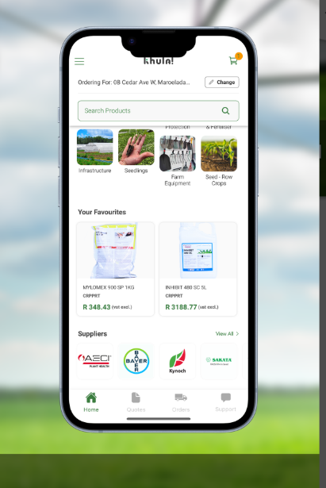
Cart Page | 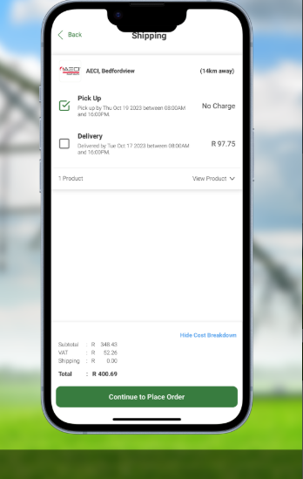
Contacts Page | 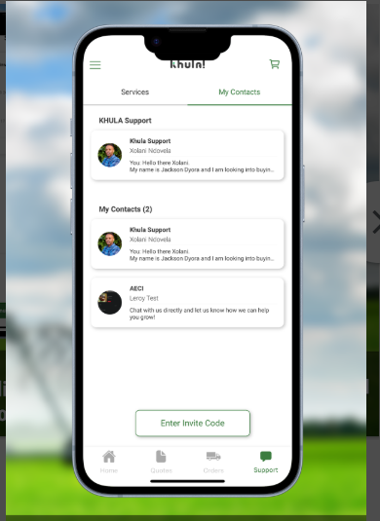
Payment Screen | 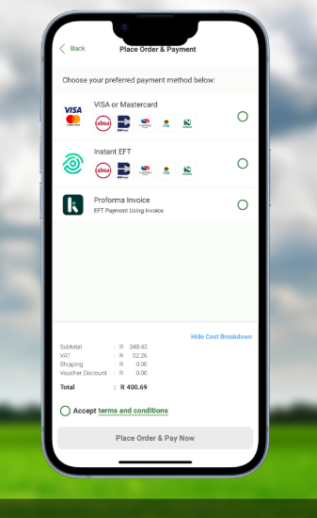

App 2: Farmer's Market

Overview of the App
Farmer's Market connects farmers with buyers of agricultural produce, letting farmers advertise produce and livestock, offering buyers location based search, and providing seller profiles with ratings and contact information. Both farmers and farms undergo a verification process for authenticity (Google Play, 2026). The app requires payment to access its core functionality, so hands on testing was not possible; however, the Google Play Store listing preview images reveal a significant finding. Listings shown in the preview display pricing in Naira rather than Rand, with seller locations including Oye, Nigeria; Plateau, Nigeria; Lagos, Nigeria; and Cross River, Nigeria. This indicates Farmer's Market, like Farmsell, is not actually built for the South African market, despite its inclusion in the original app worksheet as a South African facing comparator.

Strengths and Weaknesses
Farmer's Market's key strength, visible from listing previews, is its close functional overlap with From The Farm: location-based search, produce advertising, and trust building through seller profiles and ratings mirror the planned proximity match feed and trust rating. Its farmer and farm verification badges, visible in the preview images, are a notable trust mechanism beyond a simple star rating.
The primary weakness is the paywall gating core functionality, a substantial adoption barrier for smallholder farmers wanting to trial before committing, in direct contrast to Khula!'s account free browsing. A more significant weakness, established from the listing preview images, is that Farmer's Market is Nigeria facing rather than South African: its currency, seller locations, and presumably its supply and logistics network are built around a different country's market, the same issue found with Farmsell. It also covers crops and livestock in one undifferentiated listing model, which may reduce search precision compared to a system tuned to fresh produce with harvest date-based freshness windows, as From The Farm proposes.

Technical Implementation Theory
As hands on inspection was not possible due to the paywall, this section is based on the Google Play Store listing and its preview images only. Location based search and seller profile data suggest a client server architecture using a REST API backed by a relational or document database, with device location services feeding search queries. MVVM is again the most probable architectural choice, given the separation between browse, profile display, and advertisement creation flows. As a smaller, more narrowly scoped app than Khula!, it still uses XML layouts with ViewModel and LiveData rather than Compose native state holders. The paywall implies a subscription or account tier check gating navigation, validated server side to prevent bypass. The Naira formatted pricing and Nigeria specific location fields suggest localisation logic hard coded for the Nigerian market, like Farmsell's Uganda specific implementation, rather than a region agnostic system.

Dashboard/Home Page | 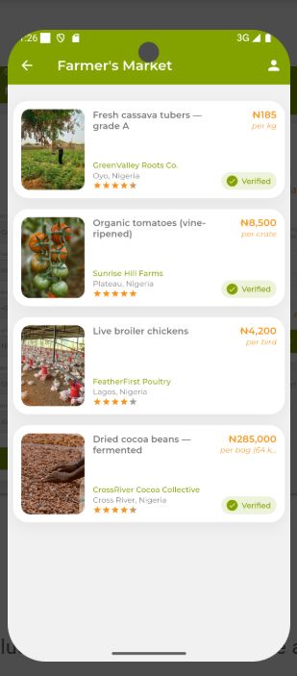
Product viewPage | 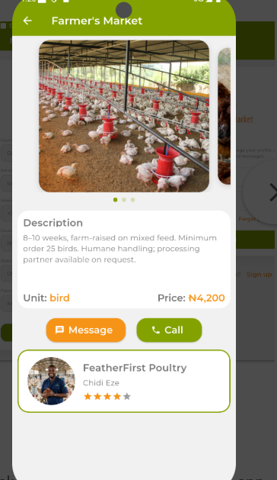
Profile, sign in, search and sell produce pages. | 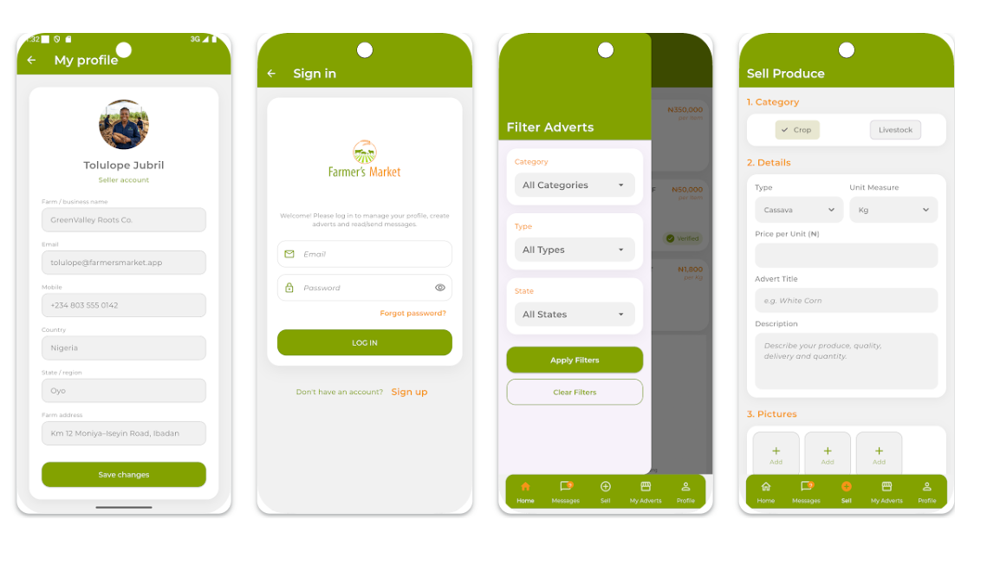

App 3: Farmsell

Overview of the App
Farmsell is a digital marketplace app for buying and selling agricultural products, allowing users to register for a free account through the mobile app on Google Play or via the Farmsell website (Google Play, 2026). Browsing was possible without an account; however, direct testing revealed a significant finding not evident from the store listing: Farmsell is a Uganda based platform, with prices displayed in Ugandan Shillings rather than South African Rand, and account registration requiring a Ugandan phone number. This changes the app's relevance as a comparator, since it is not built for the South African market or currency, despite appearing comparable from its store listing. The bottom navigation follows a standard e commerce structure of Market, Search, Orders, and Me, and produce is browsable by category, including Fruits, Bananas, Vegetables, Legumes, Spices, and Root Crops; bananas have their own top-level category, suggesting a dominant product line. The home screen features promotional banners, such as a Fresh Day discount and referral rewards, and curated sections such as Hot Deals and Vegetarian Picks with percentage off badges, giving the app a grocery e commerce feel closer to Takealot or Jumia than a farmer to buyer matching tool. Listings show bulk quantities, such as 47kg and 25kg bags, indicating the platform is oriented toward wholesale or bulk buyers rather than individual consumers.

Strengths and Weaknesses
Farmsell's clearest strength, based on user testimonials, is accessibility for first time or informal farmers. One user described starting a small farm in their village and relying on Farmsell to handle their sales, describing it as easy to use and helpful (Google Play, 2026). Browsing is accessible without login; only checkout or orders require an account, matching Khula!'s low friction pattern and contrasting with Farmer's Market's paywall.
The most significant weakness, established through direct testing, is that Farmsell is not a South African platform. Its Ugandan Shilling pricing and Ugandan phone number requirement for registration mean it operates in a different country, currency, and market, undermining its usefulness as a direct comparator despite being included in the original app worksheet. Beyond this, Farmsell shows no stated proximity or radius based matching mechanism, unlike Khula! and Farmer's Market; it is closer to a classifieds style catalogue than an automated matching algorithm. The bulk quantity listings and promotional, discount driven UX also suggest it is oriented more toward wholesale grocery e commerce than From The Farm's smallholder to buyer matching model. There is also no evidence of offline functionality, multilingual support beyond English, or biometric security, all core POE requirements for From The Farm.

Technical Implementation Theory
Farmsell's structure as an open marketplace with browsing, listing creation, and direct ordering suggests a conventional e commerce architecture: a REST API serving product or listing data, with server-side search and filtering rather than on device matching logic, given there is no indication of a proprietary matching algorithm. State management is likely handled through a standard MVVM setup. The card based promotional layout, including banners, discount badges, and curated sections observed directly in app, suggests either Jetpack Compose or a well built RecyclerView with custom view holders, more visually dynamic than a typical classifieds layout. Given the country specific currency handling and phone number-based registration tied to a specific national telecom format, localisation logic is likely hard coded for the Ugandan market rather than built as a region agnostic system, a further divergence from what From The Farm needs.

Product view Pages and payment screens | 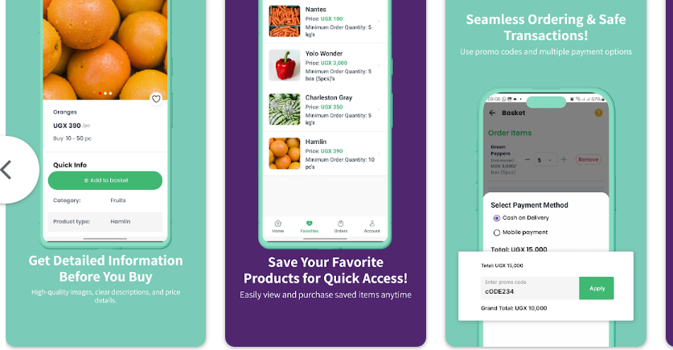
search and sell produce pages. | 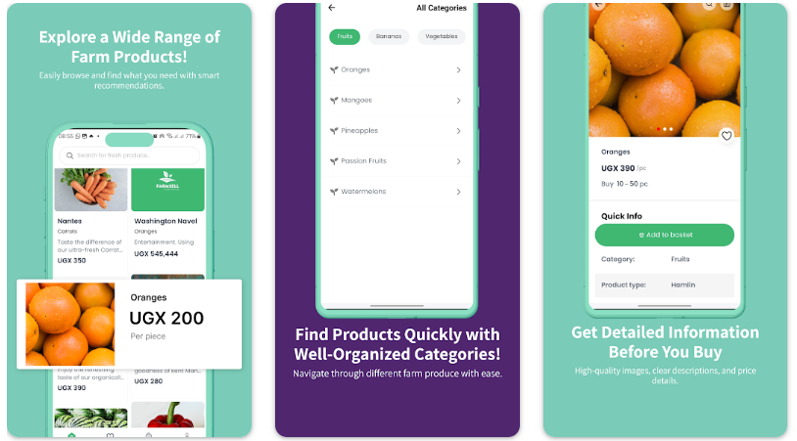

Comparison Matrix

The table below scores Khula! Inputs & Trader, Farmer's Market, and Farmsell against From The Farm across the same criteria used throughout the Competitive Analysis. Where direct testing was blocked (Farmer's Market's paywall) or a feature was simply never observed (Khula!'s testing, Farmsell's confirmed gaps), this is marked explicitly rather than assumed.
Feature | Khula! Inputs & Trader | Farmer's Market | Farmsell | From The Farm (planned)
Primary market fit | South Africa — ZAR pricing, SA founded | Nigeria facing — NGN pricing, Nigerian seller locations | Uganda based — UGX pricing, Ugandan phone number required | South Africa — built for local smallholders
Product scope | Broad ecosystem: input procurement, produce trading, financing, AI diagnostics | Narrow: crop and livestock classifieds with ratings | Broad grocery style marketplace: browsing, listing, ordering, promotions | Narrow, single purpose: proximity-based farmer-to-buyer matching only
Access friction | Account-free browsing; login only gates checkout | Paywall — subscription required to access core functionality | Account-free browsing; login only gates checkout/orders | Google Sign-In required at first launch, before any browsing
Proximity / radius matching | Location based search (manual) | Location based search (manual) | No stated proximity or radius mechanism | Automated weighted scoring: distance, crop type, quantity fit, freshness
Trust mechanism | Not described | Farmer/farm verification badges plus seller ratings | User testimonials only; no formal in-app rating system found | Thumbs-up/down rating after a completed, confirmed match
Harvest freshness awareness | Not applicable to input procurement model | Not applicable — undifferentiated crop/livestock listings | Not applicable — bulk, non-perishable-style listings | Freshness window scored against buyer deadline — core differentiator
Payments / financing | Yes — input orders, produce trading, crop-contract financing | Unclear — paywall confirmed, no evidence of in-app buyer–seller payments | Yes — marketplace checkout for produce orders | Out of scope by design — non-financial trust rating only
Offline / multilingual / biometric support | No evidence found in testing | No evidence found (inspection limited by paywall) | Confirmed absent — no offline mode, no multilingual UI beyond English, no biometric lock | Yes — offline listing/demand creation, English/isiZulu/Afrikaans, optional biometric lock
Likely architecture | MVVM; mature RecyclerView with partial Compose migration | MVVM (probable); XML layouts with ViewModel/LiveData | MVVM (probable); Compose or advanced RecyclerView | MVVM with Jetpack Compose (planned)

Conclusion

This report evaluated how three existing Android applications, Khula! Inputs & Trader, Farmer's Market, and Farmsell, approach the same broad problem as From the Farm: connecting agricultural producers with buyers while reducing dependence on middlemen. Each offers a partial rather than a complete match to From The Farm's concept. Khula! demonstrates mature, account free browsing and an innovative AI feature in KhulaLens, but its breadth across financing, procurement, and trading illustrates the complexity risk that From The Farm's narrow scope is designed to avoid. Farmer's Market shares close functional overlap in its location-based search and trust verification model, but its paywall is a significant adoption barrier, and its listing images reveal it to be built for Nigeria rather than South Africa, the same problem found with Farmsell. Farmsell, despite initial appearance as a comparable African smallholder app, was found through direct testing to be Uganda based, operating in a different currency and market, limiting its usefulness as a direct comparator while offering a useful negative case study in account free browsing and category-based produce discovery.

References

Apple App Store, 2026. Khula! Inputs. [App] Available at: https://apps.apple.com/za/app/khula-inputs/id1485013063 [Accessed 20 August 2026].
Dealroom.co, 2026. KHULA! company information, funding & investors. [online] Available at: https://app.dealroom.co/companies/khula_ [Accessed 20 August 2026].
Google Play, 2026. Farmer's Market. [App] Available at: https://play.google.com/store/apps/details?id=com.fimi.farmersmarket [Accessed 20 August 2026].
Google Play, 2026. Farmsell: Buy&Sell Agroproduce. [App] Available at: https://play.google.com/store/apps/details?id=com.farmsell&hl=en_GB [Accessed 20 August 2026].
Google Play, 2026. Khula! Inputs. [App] Available at: https://play.google.com/store/apps/details?id=za.co.khula.farmer&hl=en_ZA [Accessed 20 August 2026].
Google Play, 2026. Khula! Trader. [App] Available at: https://play.google.com/store/apps/details?id=za.co.khula.client&hl=en_ZA [Accessed 20 August 2026].
Khula, 2026. Khula | Smart Farming. [online] Available at: https://www.khula.co.za/ [Accessed 20 August 2026].
PGYER APKHUB, 2025. Farmer's Market APK for Android Download. [online] Available at: https://www.pgyer.com/apk/apk/com.fimi.farmersmarket [Accessed 20 August 2026].

